BOTTINEAU COUNTY
COMMISSIONER PROCEEDINGS
May 3rd, 2022
7:30 am

The Commissioner Meeting was called to order at 7:30 am by Chairman LeRoy Rude. A meeting of the Board of Bottineau County Commissioners was held in the Commissioner Room at the Courthouse with the following members present: LeRoy Rude, Chairman, Lance Kjelshus, Vice-Chairman, Commissioners, Jeff Beyer, Dan Marquardt, Nathaniel Buynak, and Auditor, Emily Deschamp.
Old Business:
Agenda - A motion was made to approve the agenda with the additions of The Stone Garden Grant, Les Wagner Donation and June meeting date change by Kjelshus, second by Buynak. Motion carried.
Minutes - A motion was made to approve the minutes from April 5th, 2022 by Marquardt, second by Kjelshus. Motion carried.
Consent Agenda –The monthly reports were reviewed and a motion was made to approve the consent agendas by Beyer, second by Marquardt. Motion carried.
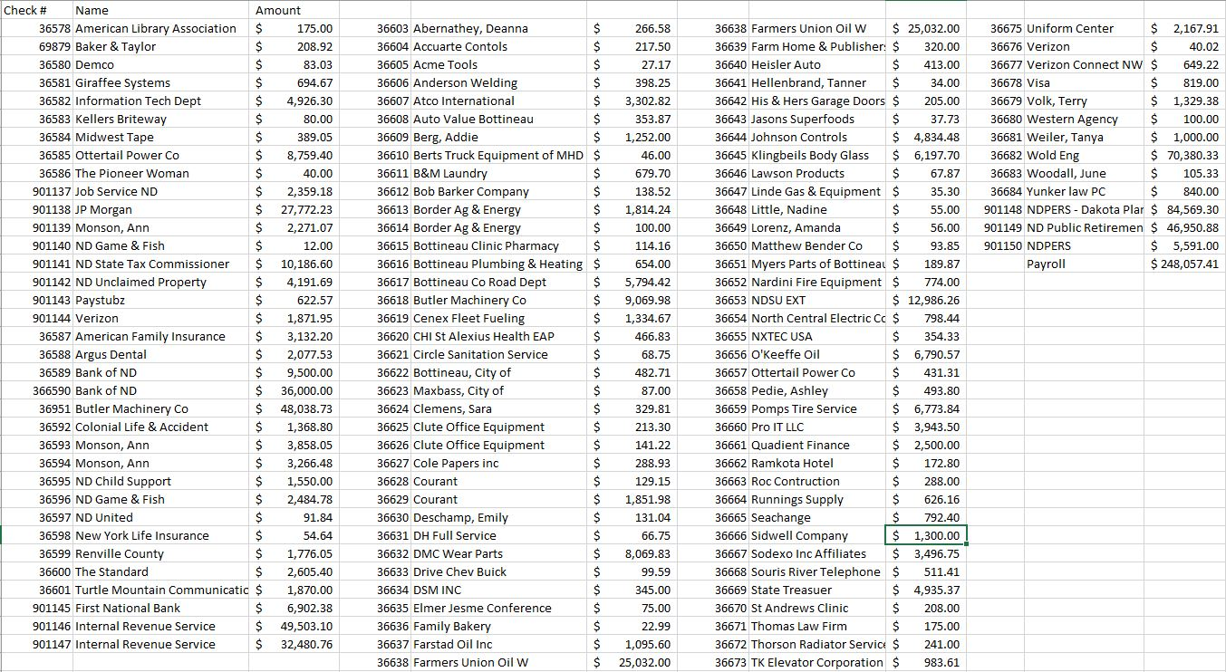
Bills – A motion was made to approve the May bills by Buynak, second by Beyer. Motion carried.

New Business:
The board was notified of a letter that was received from the Internal Revenue Service.
Emily presented the board with a Special Event Permit from Shawna’s Place in Westhope to transfer their liquor license to Thunder Mountain Speedway. A motion was made to approve the special event permit transfer for Shawna’s Place to Thunder Mountain Speedway by Kjelshus, second by Beyer. Roll call vote unanimous. Motion carried.
Emily presented the board with a Special Event Permit from A Frame Bar and Grill to transfer their liquor license to the Lake House Event Center on June 11th, 2022. A motion was made to approve the special event permits transfer for A Frame Bar and Grill to The Lake House Event Center by Beyer, second by Kjelshus. Roll call vote unanimous. Motion carried.
Emily notified the board of the conferment payment that was received from the North Dakota Insurance Reserve.
Commissioner Kjelshus spoke about the Stone Garden Grant and the Administrative pay. It was the consensus of the board to table the discussion until the June 2nd, 2022 meeting.

Kent Indvik and Seth Demontigny, Wold Engineering, gave an update on the County projects –
-Project CP-0520(022) Maxbass to Russell- Pre-construction job is scheduled for May 9th, 2022 at 1:45 am. Paving is tentatively scheduled for the beginning of June 2022.
-SC-0520(059)-Russell to Kramer-Kent updated the board on the schedule for this project. The pre-construction job is scheduled for May 9th, 2022 at 1:00 pm.
-Kent discussed the 2 quotes that he has received from Mayo Construction for the paving of the 2 north-south miles of the truck route in Bottineau (the airport road and the mile north of NDSH 5 by PCS). A motion was made to accept the Mayo Construction quote for the 2 north miles of the truck route and to utilize the ARPA funds for this project by Marquardt, second by Beyer. Roll call vote unanimous. Motion carried.
-Project BRC-0520(058)-Kramer Bridge- Kent updated the board on the meetings him and Ritch have had with Brian Fuchs with Department of Transportation. Kent and Ritch are also scheduled to meet with District 6 Representative Paul Thomas regarding this project on May 9th, 2022.
BRO-0500(059)- Souris and Willow City Box Culvert replacements-Seth discussed the pre-job construction will be set up in June of 2022 with Farden Construction.
BRO-0005(052)-Omemee Box Culvert-Seth updated the board on the seeding that will take place by Gladen Construction.
-BRP-0005(060)-Scheflo Bridge and Willow Creek box Culverts south of Overly. Surveyors have been out getting started on topos and will continue to move forward on the design of both sites after the surveys are completed. Wold engineering will continue to move forward on the design of both sites after the surveys are complete.
Ritchie Gimbel, Road Superintendent, gave an update on the County projects. Ritch discussed the fuel island that Border Ag would like to put in along Highway 20 north of the City of Newburg. After board discussion it was the consensus that Border Ag will need to apply for a variance with the Tax Director. Ritch updated the board on the recent storm. Discussion was held about the funds that were received from the pancake breakfast that was held on April 8th, 2022 for County Government month in the amount $822.00 and where the funds would be donated too.

Denise Brown, with LTAP met with the board to discuss some training that is available for the Commissioners and the Road Department.

Steve Watson, Sheriff, gave an update on the Sheriff Department activity.

Emily presented the board with a raffle permit for the Turtle Mountain Cancer Support Inc. A motion was made to approve the raffle permit for the Turtle Mountain Cancer Support by Marquardt, second by Kjelshus. Roll call vote unanimous. Motion carried.

Emily presented the board with a North Dakota EMS Foundation raffle. A motion was made to approve the raffle for the ND EMS Foundation by Kjelshus, second by Beyer. Roll call vote unanimous. Motion carried.

Emily presented the board with a letter that was received from the Bottineau Winter Park in regards to updating the T-Bar at the Winter Park. Discussion was held by the board and it was the consensus of the board to reach out to Dan Fett and Ryan Henry of the Winter Park and see if they are able to attend the June 2nd, 2022 meeting.
Department Head Meeting - Chairman Rude gave an update on the meeting and asked the department heads to give an update on their office activity. Discussion was held about the Bottineau County Storm Policy.
A motion was made to distribute the donation from the County Government month breakfast to Imagination Library and Turtle Mountain Cancer Support Inc. by Kjelshus, second by Buynak. Roll call vote unanimous. Motion carried.
Discussion was held on how the board along with the Road Superintendent and Auditor are to notify the residents of Bottineau County of the County Road and Bridge ballot measure. The measurer will be on the ballot for the June 14^{th,} 2022 primary election. Emily will reach out to the local papers to see if they would like to do an article about the Road and Bridge Levy measure.

Discussion was held with the board about the how the County payroll for the Road Department is currently processed.
Commissioner Rude notified the board that Les Wagner would like to donate 53 acres total acres of land to Bottineau County for a Memorial Park. A motion was made to accept the offer from Les Wagner with his stipulation the land is not used for farming or pasture land and to allow the land will go back to nature by Kjelshus, second by Marquardt. Discussion was held. Roll call vote unanimous. Motion carried.
Melonie Bowers, Bruce Miller and Jim Hall with the Bottineau County Parks met with the board to discuss the parks in the County. Melonie discussed widening the road to the north campground and replacing the bathroom at Carbury Dam. The edging for the playground equipment that was purchased with the help from the Garrison Diversion Grant will be installed by the Road Department when it arrives. Melonie asked for the board for another 3-yard dumpster to be placed at the Carbury Campground. A motion was made to have DSM place another dumpster at Carbury Dam by Kjelshus, second by Marquardt. Roll call vote unanimous. Motion carried.
Kristy Titus, Emergency Manager presented the board with the Emergency Snow Declaration. A motion was made to sign the Emergency Snow Declaration by Kjelshus, second by Buynak. Roll call vote unanimous. Motion carried.
Emily discussed the 2023 budget with the board. It was the consensus of the board to have each department head meet with the board to discuss their 2023 budgets a date will be set at the June 7th, 2022 commissioner meeting.
Seymour Jordan, State’s Attorney, met with the board to discuss the 30x30 Resolution for Bottineau County. A motion was made to sign the 30x30 Resolution for Bottineau County by Beyer, second by Kjelshus. Roll call vote unanimous. Motion carried.
As there was no further business, a motion was made to adjourn the meeting at 12:59pm by Marquardt, second by Buynak. Motion carried.

____________________
LeRoy Rude, Chairman

____________________
Emily Deschamp, Auditor

